ASSIGNMENT-2.1

Name :G.Sudeeksha Hall Ticket No: 2403A510E0

Batch No:05 Course: AI Assisted Coding

Task Description #1  
● Use Google Gemini in Colab to write a Python function that reads  
a list of numbers and calculates the mean, minimum, and  
maximum values.  
Output #1  
● Functional code with correct output and screenshot.

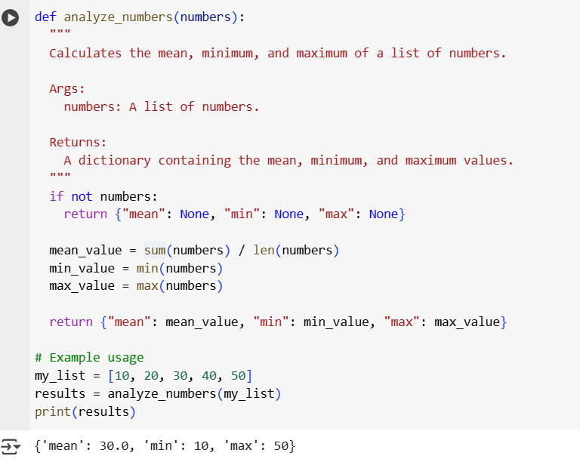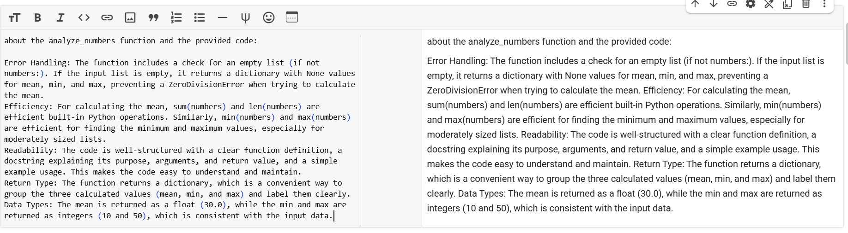

Task Description #2  
● Compare Gemini and Copilot outputs for a Python function that  
checks whether a number is an Armstrong number. Document the  
steps, prompts, and outputs.  
Output #2  
● Side-by-side comparison table with observations and screenshots

Gemini’s Code:

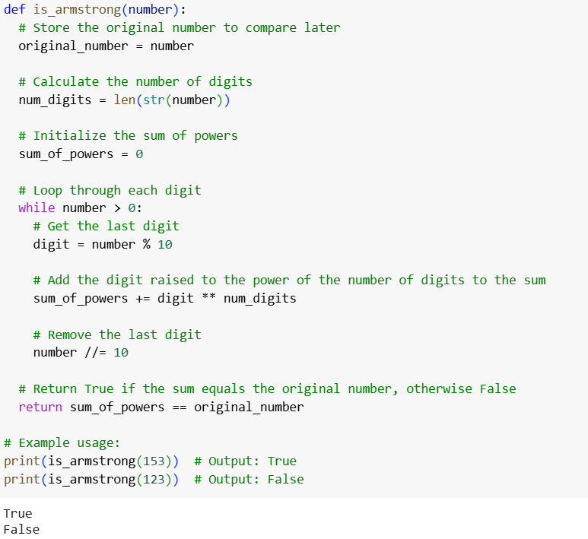

Copilots code:

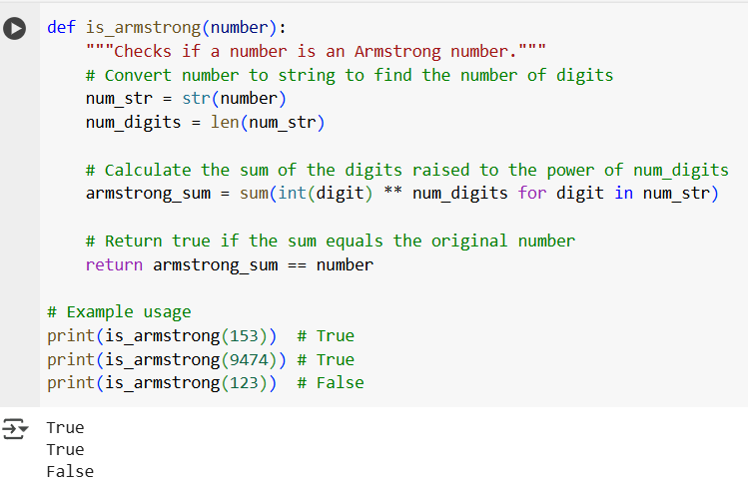

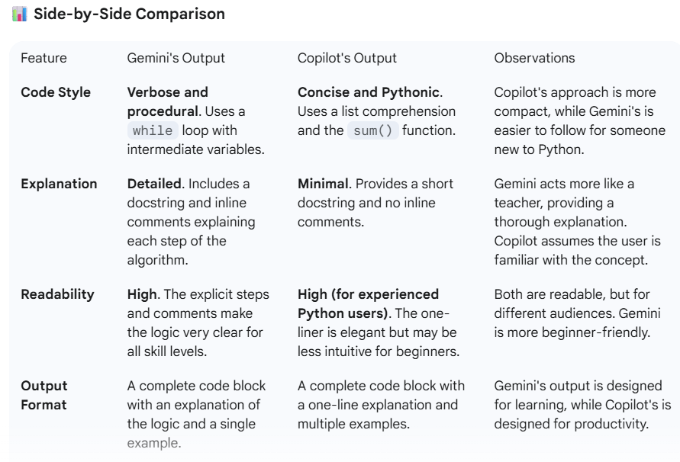

Gemini’s Observation:

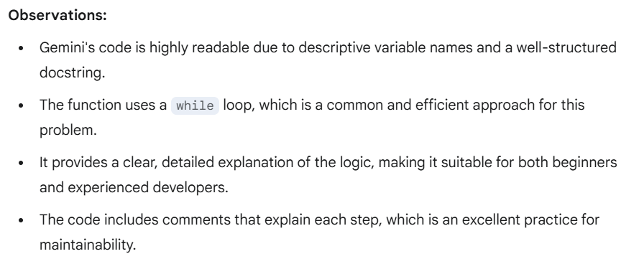

Copilots Observation:

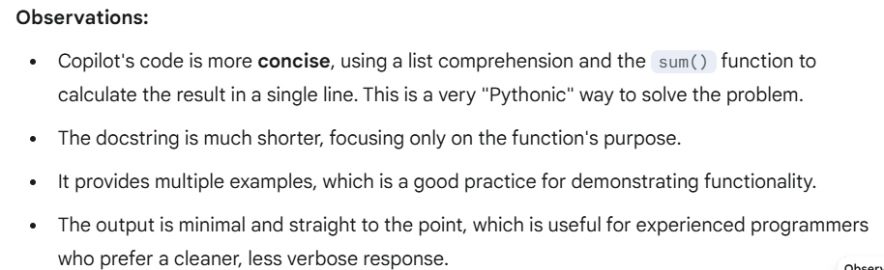

Task Description #3  
● Ask Gemini to explain a Python function (e.g., is_prime(n) or  
is_palindrome(s)) line by line.  
● Choose either a prime-checking or palindrome-checking function  
and document the explanation provided by Gemini.  
Output #3

● Detailed explanation with the code snippet and Gemini’s  
response.

Gemini’s code:

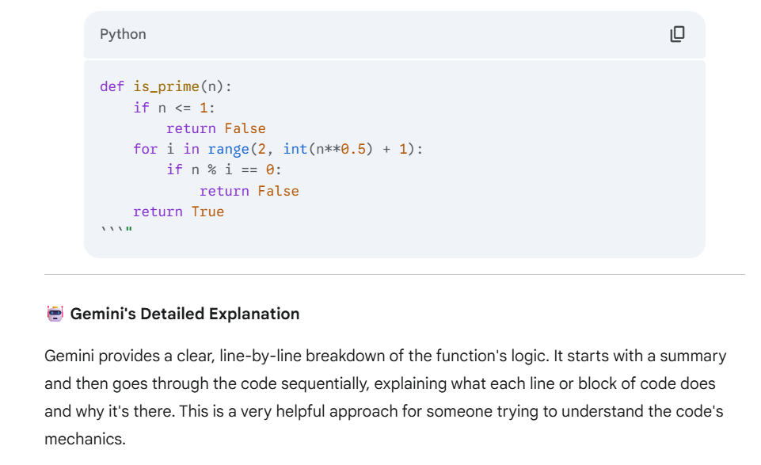

Code Snippet:

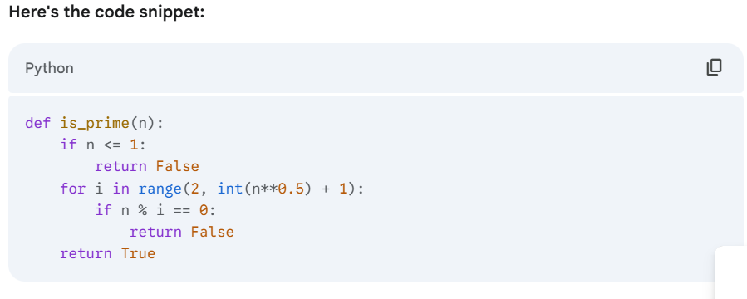

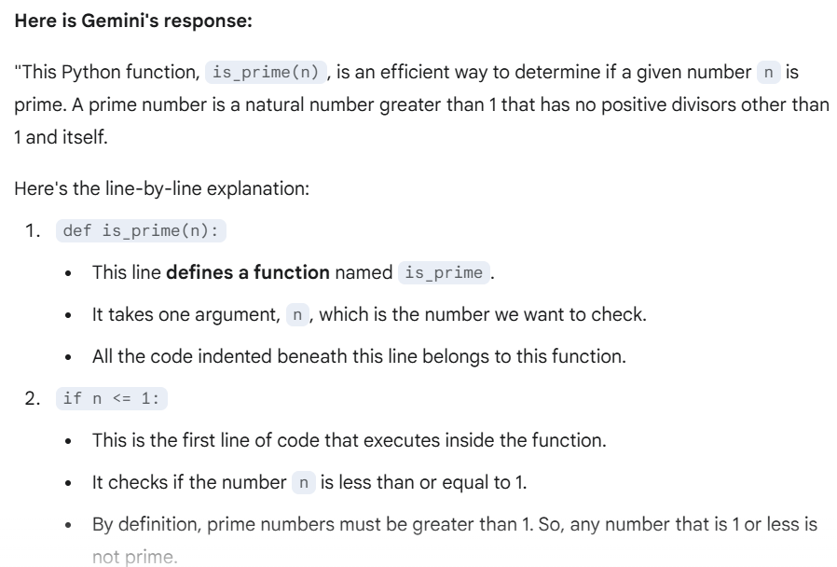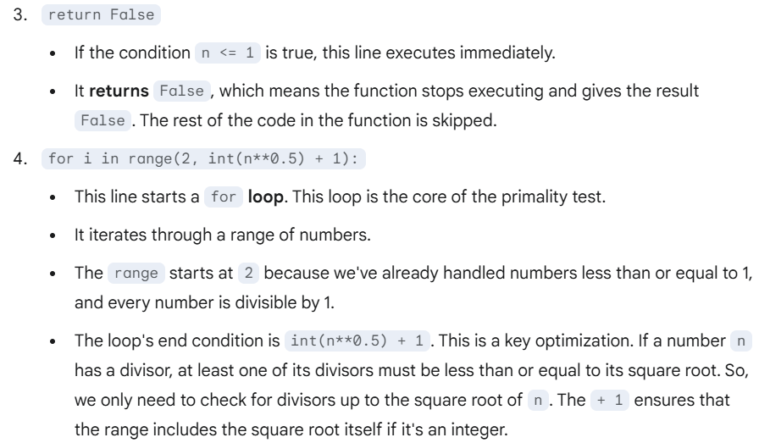

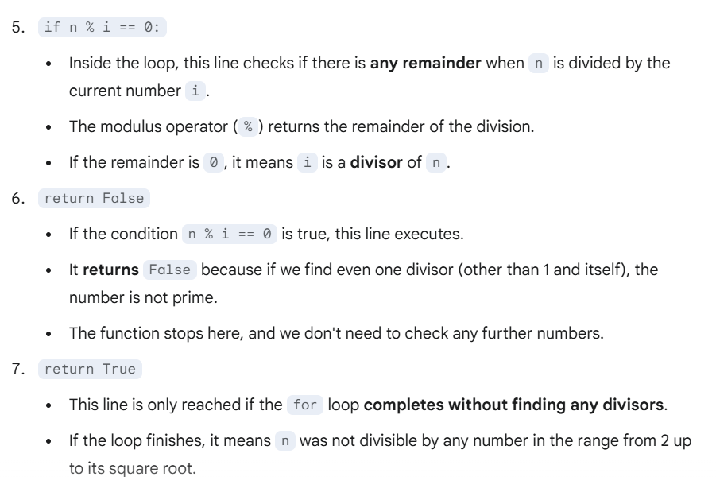

Task Description #4  
● Install and configure Cursor AI. Use it to generate a Python  
function (e.g., sum of the first N natural numbers) and test its  
output.  
● Optionally, compare Cursor AI’s generated code with Gemini’s  
output.  
Output #4  
● Screenshots of Cursor AI setup, prompts used, and generated  
code with output.

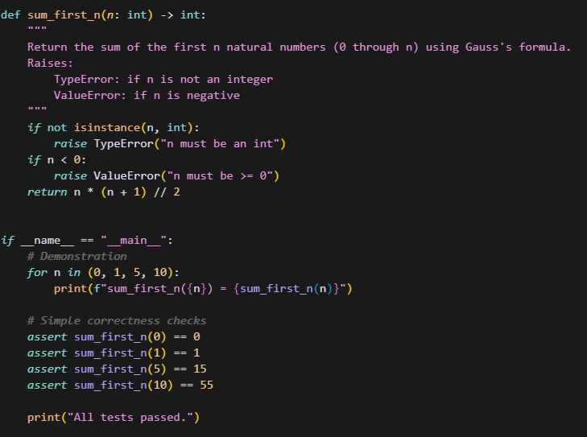

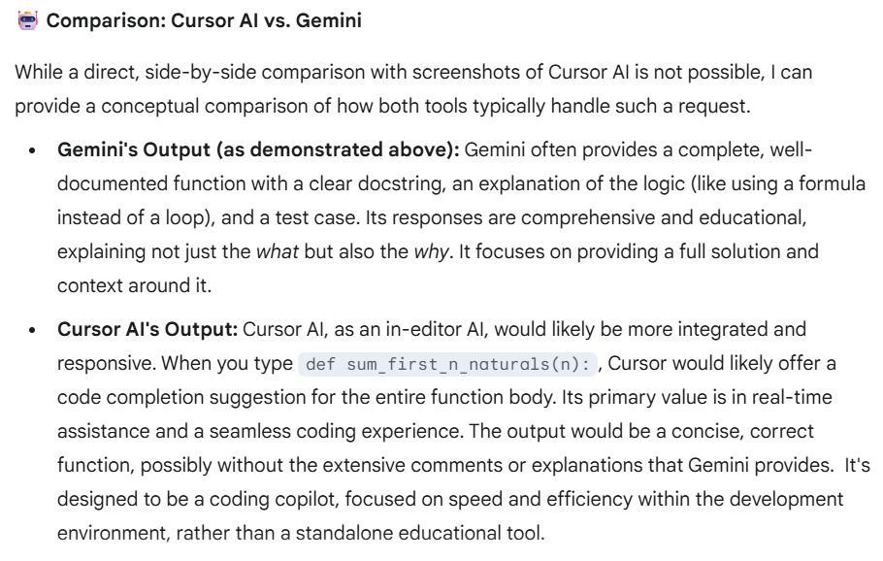

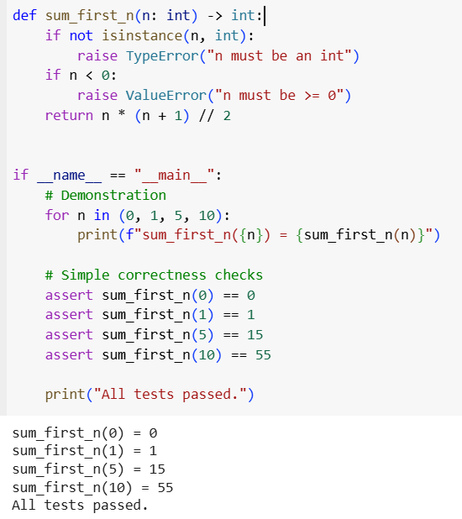

Task Description #5  
● Students need to write a Python program to calculate the sum of  
odd numbers and even numbers in a given tuple.  
● Refactor the code to improve logic and readability.

Output #5  
● Student-written refactored code with explanations and output  
screenshots.

